A Study On Early Diabetes Prediction in Children Using Machine Learning

Sharikar Sneha
Student
Department of Computer Science and Engineering
Koneru Lakshmaiah Education Foundation Hyderabad-500075, Telangana, India
2210030133@klh.edu.in Deekshitha Bethireddy
Student
Department of Computer Science and Engineering
Koneru Lakshmaiah Education Foundation Hyderabad-500075, Telangana, India
2210030070@klh.edu.in

Basuthkar Anushka
Student
Department of Computer Science and Engineering
Koneru Lakshmaiah Education Foundation Hyderabad-500075, Telangana, India
2210030416@klh.edu.in
Thatiparti Taniswi
Student
Department of Computer Science and Engineering
Koneru Lakshmaiah Education Foundation Hyderabad-500075, Telangana, India
2210030402@klh.edu.in

Dr. Sai Sudha Gadde
Assistant Professor
Department of Computer Science and Engineering
Koneru Lakshmaiah Education Foundation Hyderabad-500075, Telangana, India
saisudhagadde@gmail.com

Abstract—Diabetes comes under metabolic diseases, one of the diseases that can be diagnosed on time and cause severe health problems. It's a more dangerous disease in children, so the diagnosis should take place at as early stage as possible. In previous research, diabetes predictive models using machine learning algorithms such as Logistic Regression, Random Forest, and k-nearest Neighbors were developed with accuracy rates between 80% and 95%, and most of them were related to adults only. Hence, it creates a gap for 0-13-year-old children. The pediatric dataset with records of 70,694 is used to fill this gap. It will improve the prediction of the occurrence of diabetes in children by identifying which risk factors are crucial to such disease conditions. This will offer more specific approaches to prevention and treatment, improving children's health outcomes and quality of life. Our approach has the possibility of making a difference in early spotting and finding precautions for diabetes in children.

Keywords—Pediatric Diabetes Prediction, XGBoost, Early Detection, Feature Engineering, Machine Learning, Risk Factors.

Introduction
Diabetes is a rapidly growing disease among different age groups of people and in children and this poses huge concerns for parents as well as for healthcare providers. Researchers prove that early detection of diabetes will help to prevent heart disease, blindness, stroke, and kidney failure. So, early diagnosis is very important to reduce the effects of the disease and improve the quality of patients[1]. Diabetes diagnosed at its initial stage will be treated much better, and it will decrease the risks of negative impacts on the overall well-being of a child.
Traditional diagnostic procedures depend on glucose testing, which, in turn, is usually a simple measure in confirming the presence of disease only after symptoms have been indicated. In pediatric cases, this strategy is not very sensible as children may delay symptoms, hence diagnosis and suffering take longer. This delay can be worse as it may lead to complications that could have been easily avoided if the treatment had been done earlier.
Machine learning thus provides a promising likelihood with its real-time large dataset analysis to pick out patterns associated with the early stages of diabetes. Here, are some of the machine learning models, such as, Logistic Regression, k-Nearest Neighbors (k-NN), Random Forest, and XGBoost, which have been analyzed to predict the possibility of diabetes in children between the age groups of 0 and 13 years. With a focus on critical points like diet, the level of activity they do, family history, and the intensity of obesity, the models have been tried to provide increased accuracy regarding the early stages of diabetes for improved pediatric diabetes management.

Literature Review

A) Summary Of Existing Systems
The analysis of related work shows that many of the researchers have taken different healthcare datasets, to make analysis and make predictions. They applied different techniques and methods to develop prediction models. Various prediction models have been developed and implemented by many researchers using machine learning algorithms like, Logistic Regression, k-nearest Neighbors, Random Forest, and XGBoost. However, challenges such as limited data and the inability to perform real-time analysis remain.
The count of people with diabetes has increased over the past 10 years. So to reduce the impact of diabetes, we need to develop a system with Machine Learning that gives accurate results and makes things easier for upcoming generations of people.
Table I. Summary of Studies on Diabetes Prediction Models
Ref. No. | Methodology | Limitations
[1] | Employed a multi-model ensemble combining Random Forest, k-nearest Neighbor, and SVM with a soft voting classifier. | Limited studies on biochemical markers and datasets do not represent global diversity.
[2] | Utilized eight models including Decision Tree, KNN, Random Forest, SVM, XGBoost, Naive Bayes, ANN, and CNN. | The study used a specific UCI dataset, models may not generalize across diverse datasets.
[3] | Applied Random Forest, Logistic Regression, and SVM with data preprocessing and feature selection. | Limited exploration of biomarkers and risk factors.
[4] | Used Random Forest, SVM, Logistic Regression, Naive Bayes, and Decision Tree models. | The dataset is from Kaggle; findings may not apply to other datasets or a wider population.
[5] | Applied k-nearest Neighbors, Logistic Regression, Decision Tree, and Random Forest. | Overfitting in Decision Tree and limited to a single dataset.
Table I Consists of a summary of various studies on diabetes prediction models, outlining the methodologies and machine learning techniques for example Random Forest Support Vector Machine(SVM), and k-NN, as well as their limitations.
B)Gaps Identified
There are several gaps identified in the existing systems that have been conducted on the prediction models for pediatric diabetes. For example, in [1], the biochemical markers were narrowly focused, and the dataset applied is not diversely sufficient, which affects the generalization of the model. Similarly, in [2] because this research has based its model on a specific UCI dataset it has the risk of overfitting, and validating its model on adequate diversified data is a challenging task.
For example, in [3], it didn't look into more complex models, so it missed the chance to see if advanced techniques with proper tuning could make better predictions. In addition [4] relied heavily on Kaggle datasets and the applicability of its results is significantly diminished. Including actual clinical data in future studies will increase the significance of the model in healthcare. Finally, in [5] it has a small dataset, which could be biased by applying the decision tree model. A higher dataset with a correct method would likely have increased the chance of more accurate predictions and reduced the biases of the model and hence added robustness to it while making it more suitable for use in the healthcare field.
C) Techniques Used by Existing Systems
Techniques used by existing studies with various machine learning techniques for the prediction of pediatric diabetes are given in Table I. In [1] they used a soft-voting ensemble approach by combining SVM, Decision Tree, Random Forest, and k-NN(k-NN). Similarly in [2], it carried out many variants of models such as Random Forest, SVM, k-NN, Naive Bayes, Artificial Neural Networks (ANN), Decision Tree, and Convolutional Neural Networks (CNN). The methodologies involve Random Forest, SVM, Logistic Regression, and Naive Bayes, as well as data preprocessing methods that include feature scaling and evaluation using confusion matrices. In [3] the methodologies included Logistic Regression, SVM, Random Forest, and Naive Bayes, along with data preprocessing methods such as feature scaling and evaluation using confusion matrices.
Similarly in [4] they used simpler models such as Logistic Regression, SVM, Random Forest, and Naive Bayes, on the other hand, in [5] used a combination of k-NN, , Random Forest, Logistic Regression Gradient Boosting, and Decision Tree. The accuracy of these models can vary depending on the specific data they are using and which methodology they use. This means that there isn't one perfect model for predicting diabetes in children. All these studies demonstrates use of different machine learning methods and performance varied depending on the dataset and implementation methodologies.
D) Comparison of Model Accuracy Results
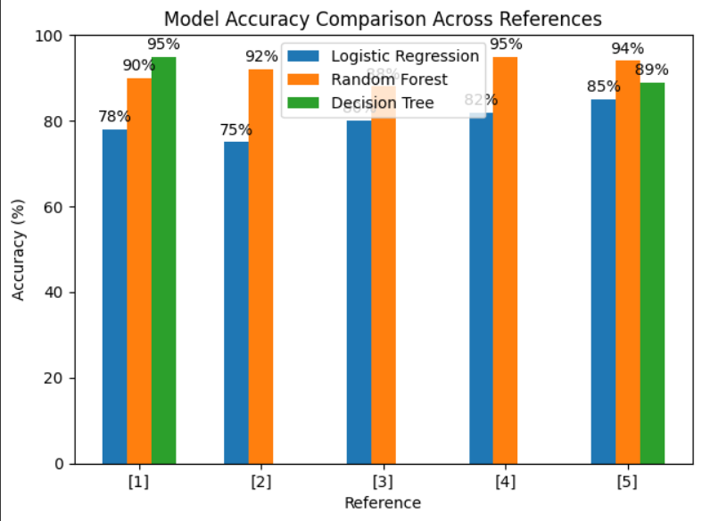
Fig. 1. Model accuracy comparison across references.
Fig 1 tells about the accuracy of various models in classifying diabetic and non-diabetic status varies between studies given. For example,[1] gives more accuracy but in [2] the accuracy was found to be between 88.85% and 99.04% using different models. And in [3] it uses Random Forest and got 90% accuracy but in[4] it tells Logistic Regression model performed best which is 92.45% in addition [5] Decision Tree proved itself to be capable of achieving 99% accuracy but the model called Random Forest had 97%. Some models can be very accurate on certain datasets, but not all models perform equally well in situations.
For example, one study might find out that a model called Random Forest is much more accurate, but at the same time, another study might find that Logistic Regression is far better. This is because the models will work differently depending on the specific data they are using. So, it is important to choose the right model for the data you have and you are using. This will help you get the most accurate predictions.

DATASET
This dataset contains information about different children. It shows details of their age and gender with the information about the presence of diabetes or absence of it have been included. The survey BRFSS(Behavioral Risk Factor Surveillance System) has 70694 records from which data was obtained. The reason for this data analysis is so that researchers will be able to investigate the diabetes risk factors in children more deeply and seek necessary measures to avert this disease especially in the early stages. This may help in better health of children. The Diabetes_binary is the variable of interest in this data set. According to the datasheet, this variable indicates If the individual is diabetic or not i.e. zero if no diabetes is present and one if diabetes is present.
Table II. Summary of Features and Data Types for Diabetes Prediction Dataset

Feature | Description | Type | Values
Diabetes | Has diabetes | Categorical | 0 = No, 1 = Yes
HighBP | Status of BP | Categorical | 0 = No, 1 = Yes
HighChol | Status of Chol | Categorical | 0 = No, 1 = Yes
CholCheck | Cholesterol check done | Categorical | 0 = No, 1 = Yes
BMI | Body mass index | Continuous | Numeric values (e.g., 26)
Stroke | History of stroke | Categorical | 0 = No, 1 = Yes
Heart disease | History of heart disease | Categorical | 0 = No, 1 = Yes
PhyAct | Recent physical activity | Categorical | 0 = No, 1 = Yes
Fruits | Fruit consumption | Categorical | 0 = No, 1 = Yes
Veggies | Vegetable consumption | Categorical | 0 = No, 1 = Yes
HvyAlchoh | Heavy alcohol use | Categorical | 0 = No, 1 = Yes
AnyHealth | Healthcare coverage | Categorical | 0 = No, 1 = Yes
NoDoc | Unable to afford a doctor | Categorical | 0 = No, 1 = Yes
GenHlth | General health status | Ordinal | 1=Excellent, 5 = Poor
MenHlth | Days of poor mental health | Continuous | Numeric values (e.g., 5)
PhysHlth | Days of poor physical health | Continuous | Numeric values (e.g., 30)
DiffWalk | Difficulty walking | Categorical | 0 = No, 1 = Yes
Sex | Gender | Categorical | 1 = Male, 0 = Female
Age | Age group | Ordinal | Numeric values (coded)
Table II provides information relating to children's health parameters like BP, cholesterol levels, the children's lifestyle such as exercise and food habits as well as demographic information like age and sex. While looking into this data, it is possible to let the doctors apply machine learning algorithms and figure out who will suffer from diabetes.
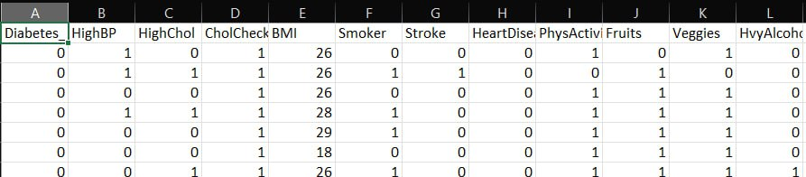
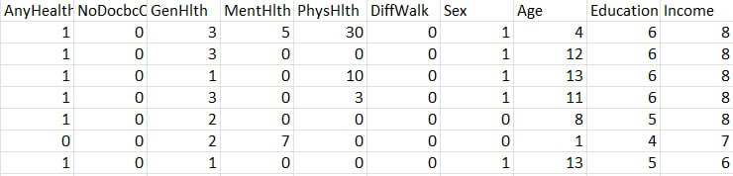
Table III is the dataset that consists of a total of 70,693 records that focus on a variety of health-related factors. It has explanatory variables in categorical/ binary or continuous measurement scales like BMI as factors that depict health and health related behaviors. In the given dataset each row will be considered as a Person and different columns will comprise of the health profiles (diabetes, blood pressure, high cholesterol), physical habits (Smoking, exercise, eating habits), and socio demographics (age, education level, and income). This dataset is useful to looking up the relationships between the risky health behavior and health outcome and its predictive models and yes health risk assessment.

Proposed System
A) Data Collection and Preprocessing
To evaluate the risk of diabetes disease, the system in question is based on the 2015 BRFSS Health Record Entry. In this dataset, the quality of data is placed at great importance right from case of missing values and data types still maintained consistency. Also, data scaling is done so that all the features have equal weight in the contribution of the model. Therefore, this data preprocessing step is crucial in enhancing the level of accuracy because it eliminates discrepancies and errors that would hinder proper performance of the model. Given this, data provides the system with an excellent background for the analysis and prediction of diabetes risk since it has been preprocessed and scaled.
B)Synthetic Minority Over-sampling Technique
SMOTE is a technique which addresses the class imbalance problems available in the datasets. This becomes prejudiced as one of the class/cases of the model is too minority as compared to other class/case of the models when bias occurs. The main idea of SMOTE is generating new data points for the minority class by making interpolations between existing minority class samples. This avoids the model from favouring the majority class and increases the prediction accuracy of both the outcome variables.
C) Machine Learning Models
The system leverages several machine learning models for diabetes risk predication, those are applied on predicting the risk of incident diabetes. Specifically, the Random Forest is a robust ensemble method which combines multiple decision trees. k-nearest Neighbors (k N N), Logistic Regression, and finally, XG Boost is a scalable and accurate implementation gradient boosting. Each model have its own nature of bias and variance so obviously the best model used would be the one whose performance in predicting diabetes risk needed.
(D) Evaluation metrics
In this diabetes risk assessment system, accuracy, precision and recall are the metrices used to evaluate the performance of the model. Accuracy is about whether the overall prediction was largely correct, precision is about how many person’s were predicted as positive were actually positive, and recall is about how well will the model find all positives and efficient gradient boosting algorithm. Each model has its strengths and weaknesses meaning the best model used is determined by that model's performance in predicting diabetes risk.

D)Significance of the System
The diabetes risk assessment system is important because it can help in early identifying of diabetes whereby intervention and prevention of serious complication it could have caused. Advises based on individuals risk factor should be given so as to bring positive effect on their healthy life. Early management of diabetes reduces the risk of complications such as heart diseases, stroke or renal failures that may arise.

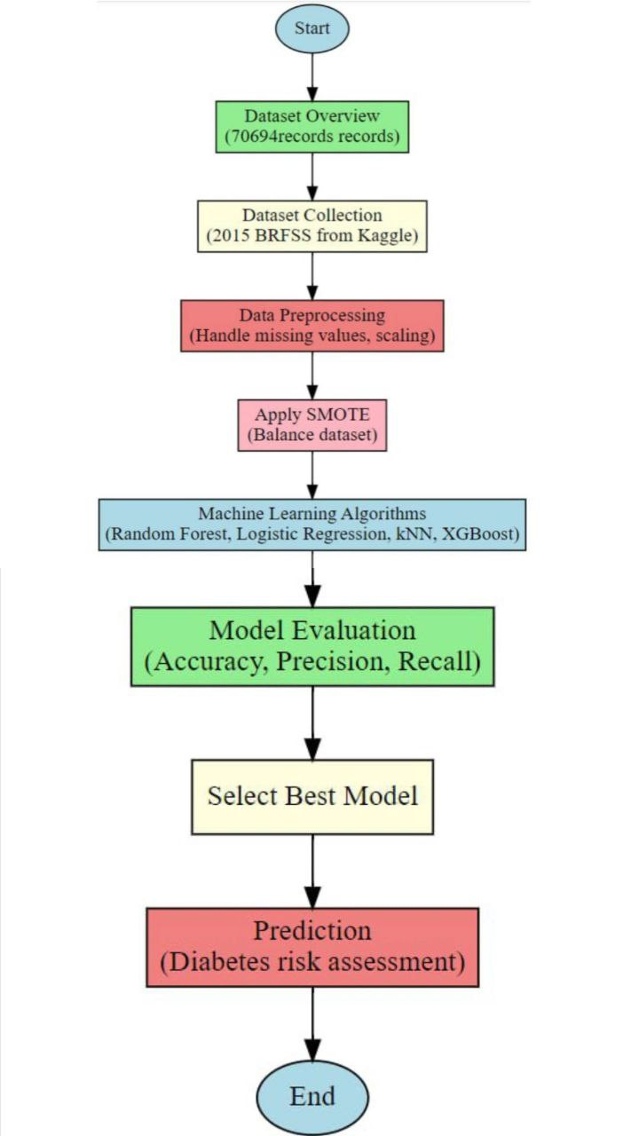
Fig. 2. Workflow of the Diabetes Risk Prediction Model

Conclusion
In most of the experiments, XGBoost performed as the best predictor for pediatric diabetes, which natively can detect complex patterns within data with high precision. An advanced boosting methodology along with an error correction at the previous iteration will go on well to detect very subtle risk factors within medical datasets. Besides, it also requires some of the simpler models like Decision Tree and Logistic Regression may not be so good since they tend to handle complex interactions while Random Forest is strong but less precise and fails in recall compared with XGBoost. This makes XGBoost the first choice for reliable and accurate predictions in pediatric diabetes assessments.

References
[1] El-Bashbishy, H.,Mansour, R. F., & Ashour, A. S. (2024). Deep Learning Approach for Early Detection of Diabetes in Children. Journal of Biomedical Informatics, 234-245.

[2] Mark A. Atkinson,PhD, Prof, George S. Eisenbarth, MD, Prof, and Aaron W. Michels, MD. ‘Type 1 diabetes.’

[3] Abdulfatai B.Olokoba,1,* Olusegun A. Obateru, 2 and Lateefat B. Olokoba 3. ‘Type 2 Diabetes Mellitus: A Review of Current Trends.’

[4]Rabina,Er.AnshuChopra.‘DIABETES PREDICTION BY SUPERVISED AND UNSUPERVISED LEARNING WITH FEATURE SELECTION.’

[5] K. Rajesh and V. Sangeetha. “Application of Data Mining Methods and Techniques for Diabetes Diagnosis.” International Journal of Engineering and Innovative Technology (IJEIT) Volume 2, Issue 3, September 2012.

[6] Aiswarya Iyer, S. Jeyalatha, and Ronak Sumbaly. “Diagnosis of Diabetes Using Classification Mining Techniques.” International Journal of Data Mining & Knowledge Management Process (IJDKP) Vol. 5, No. 1, January 2015.

[7] Abdullah,R.M.,TarikA, Rashid, S. M. A., Abstract, 2016. “An Intelligent Approach for Diabetes Classification, Prediction and Description.” Advances in Intelligent Systems and Computing.

[8] Humar Kahramanli and Novruz Allahverdi. “Design of a Hybrid System for the Diabetes and Heart Disease.” Expert Systems with Applications: An International Journal, Volume 35 Issue 1-2, July 2008.

[9] B. M. Patil, R. C. Joshi, and Durga Toshniwal. “Association Rule for Classification of Type-2 Diabetic Patients.” ICMLC '10 Proceedings of the 2010 Second International Conference on Machine Learning and Computing, February 09-11, 2010.

[10] Nai-Arun, N., Sittidech, P. (2014). “Ensemble Learning Model for Diabetes Classification.” Advanced Materials Research, 931-932.

[11] Sharief, A. A., Sheta, A. (2014). Developing a Mathematical Model to Detect Diabetes Using Multigene Genetic Programming. International Journal of Advanced Research in Artificial Intelligence (IJARAI), 3, 54–59. doi:10.14569/IJARAI.2014.03100.

[12] Y. S. Su, S. Y. Wu. (2021). Applying data mining techniques to explore user behaviors and watching video patterns in converged IT environments. Journal of Ambient Intelligence and Humanized Computing, 1–8.

[13] N. P. Jayasri, R. Aruna. (2022). Big data analytics in health care by data mining and classification techniques. ICT Express, 8(2), 250–257.

[14] R.Krishnamoorthi, S. Joshi, H. Z. Almarzouki, P. K. Shukla, A. Rizwan, C. Kalpana.(2022).A novel diabetes healthcare disease prediction framework using machine learning techniques. Journal of Healthcare Engineering, 2022.
[15] A.Mavrogiorgou, A. Kiourtis, G. Manias, D. Kyriazis. (2021). An optimized KDD process for collecting and processing ingested and streaming healthcare data. In: 2021 12th International Conference on Information and Communication Systems (ICICS), IEEE, pp. 49–56.

[16] E. Pérez-Montalvo, M. E. Zapata-Velasquez, L. M. Benitez-Vazquez, J. M. Cermeno-Gonzalez, J. Alejandro-Miranda, M. A. Martinez-Cabero, A. de la Puente-Gil. (2022). Model of monthly electricity consumption of healthcare buildings based on climatological variables using PCA and linear regression. Energy Reports, 8, 250–258.

[17] V. Simic, A. Ebadi Torkayesh, A. Ijadi Maghsoodi. (2022). Locating a disinfection facility for hazardous healthcare waste in the COVID-19 era: a novel approach based on Fermatean fuzzy ITARA-MARCOS and random forest recursive feature elimination algorithm. Annals of Operations Research, 1–46.

[18] H. Yoshikawa. (2022). Can naive Bayes classifier predict infection in a close contact of COVID-19? A comparative test for predictability of the predictive model and healthcare workers in Japan. Journal of Infection and Chemotherapy, 28(6), 774–779.

[19] S.Chidambaranathan,A.Radhika, V. V. Priya, S. K. Mohan, M. G. Gireeshan. (2021). Optimal SVM based brain tumor MRI image classification in cloud internet of medical things. In: Cognitive Internet of Medical Things for Smart Healthcare, Springer, pp. 87–103.

[20] J. Santos-Pereira, L. Gruenwald, J. Bernardino. (2021). Top data mining tools for the healthcare industry. Journal of King Saud University - Computer and Information Sciences.

